**Experiment-5**

**AIM: Develop a program for Bias, Variance, remove duplicates, Cross Validation:**

**Install module from terminal:**

**>pip install mlxtend**

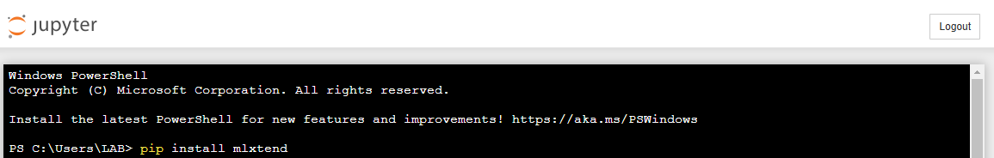

**import csv file housing.csv from path or user and enter the path where it exists:**

**for example: 'D:/housing.csv'**

**program:**

from pandas import read_csv

from sklearn.model_selection import train_test_split

from sklearn.linear_model import LinearRegression

from mlxtend.evaluate import bias_variance_decomp

import numpy as np

# Load dataset

url = 'D:/housing.csv'

dataframe = read_csv(url, header=None)

# Separate into inputs and outputs

data = dataframe.values

X, y = data[:, :-1], data[:, -1]

# Ensure that X and y are numpy arrays

X = np.array(X)

y = np.array(y)

# Split the data

X_train, X_test, y_train, y_test = train_test_split(X, y, test_size=0.33, random_state=1)

# Define the model

model = LinearRegression()

# Estimate bias and variance

mse, bias, var = bias_variance_decomp(model, X_train, y_train, X_test, y_test, loss='mse',

num_rounds=200, random_seed=1)

# Summarize results

print(f'MSE: {mse:.3f}')

print(f'Bias: {bias:.3f}')

print(f'Variance: {var:.3f}')

Output:

MSE: 135.372

Bias: 113.311

Variance: 22.061